Zurker
The future competitor of FACEBOOK!
Zurker which is owned by some intelligent minds in the Silicon Valley have found out a way to beat Facebook in competition, something which even Google Plus of the unbeatable Google failed in accomplishing. And it is because the social network competition has made it do like that. Zurker is the new way of succeeding the market. So, earlier you join, you get the most profit as well as the slice of the pie it will generate in the near future, which Zurker calls as the Vshares.
What gives Zurker an edge over other social networking sites is their new scheme of alluring people by their all-time weakness – MONEY and FRIENDS. Zurker is the new revolution to the Social Networking industry. It is because unlike Facebook, it does not get hold of every earning they generate from the users. Rather it gives you a share of the earning via shares (Vshares) which will keep on increasing as time goes on and more and more members join the site. So, by joining and referring more members, you are profiting yourself. This means that Zurker isn’t owned by few venture capitalists who stand to make billions and billions.
As Zurker’s page says, it is driven by us, “The Users” and a full democracy is maintained. In Zurker the only thing is to build a great platform for the people and make the web a great place to interact with a sole focus on people. This is because social networks are churning up the user interest to money, why not we the users get the most out of it and get some of the earning. So, in real terms what made Facebook great, that can be made by us-the only huge difference being we’ll be the ones earning from it as it gets valuable more and more.

A little walkthrough the other distinguishing features of Zurker
- ZURKS
Zurks are important on Zurker. Zurks are what our friends at Facebook/Twitter refer to as "like," "recommend," or "share." To Zurk means to appreciate the fact that the member shared the information. It means to support the intent behind the act of sharing, and it can mean to like, to love, to commiserate, to respect, to admire - as appropriate for the occasion.
Members can zurk your posts, photos, comments, and just about everything. Your zurk count is shown on your profile and also, in some areas, as a little number following your name, like this.
Jack¹⁵²

Your zurk count goes up when one of your items is zurked, it goes without saying, but also when you zurk something.
- Connections and Subscriptions

To connect with someone is to establish a two-way connection, sort of like becoming friends on Facebook. One member initiates the connect, the other accepts it or rejects it.

However if you are a celebrity and millions of people want to connect with you , the easiest way to handle such a situation is to restrict your connects! Only those with the required information (such as your mobile phone number, or the name of your pet) will be able to connect with you.

A subscription is a one-way follow like you have on Twitter or Google Plus. The difference - and this is a very crucial difference - is that members are not notified when someone subscribes. This is to discourage indiscriminate subscriptions aimed solely at generating reciprocal subscriptions, also known as SPAM.

- Nickname Aliases
This is a cool little feature unique to Zurker. If you've known your baby brother as "Jacky" all his life, then you can set a nickname so that he appears to you as "Jacky" whether he sets his display name as his real full name or some other nickname. The nickname is for your convenience only and is seen by no-one, not even Jacky himself.
The names of members in your contacts with nicknames you've set appear in italics.
- Street And Home

At Zurker all the incoming news are classified as Street or Home.
Under Home goes news that affects you directly, such as someone commented on your photo, initiated a convo with you, zurked your update, replied to your comment, and so on.
On the Street, meanwhile, you will find out what's been happening with your contacts or subscriptions. If someone posts an update or uploads a photo, you'll see it on Street.
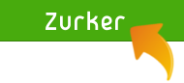
To get to your Streeme (Street + Home) from anywhere on Zurker, simply click on the Zurker logo.

- Tags

Tags are Zurker's powerful way of ensuring that you stay in control. When you connect with a member, you tag him/her with a tag of your choice. For example, a classmate might be tagged as "school." Someone at work might be tagged as "office." The tags you apply to people are seen only by you and never by anyone else.

When you post an update, you can specify your audience by checking the tags. This determines who will receive news about the update. For example, if you are posting about a bake sale, you might check the tags "school" and "scouts". If you are posting about something that is office related , you might check the tag “office”.

Similarly, you can quickly and easily check or uncheck tags when on the Street, to filter what you see. Uncheck "morons" and you won't get any news from people whom you tagged as "morons." Uncheck everything except "family" and you'll find out only what's happening with your blood relatives only.

Zurker lets you use tags to make sure you don't suffer information overload, your online activities stay super-organized, and your privacy is protected. Tags control both incoming and outgoing data.
All of your contacts - friends, family members, colleagues, etc - must be tagged with one or more tags. You do this when the connect is established. By default, no tags are associated with the member. In the screenshot below, they are all turned off.
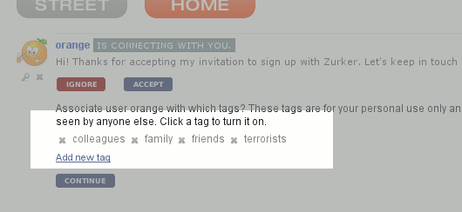
Just click on a tag to turn it on. In this case, Orange is a friend we hang out with a lot. So we click on 'friends'.
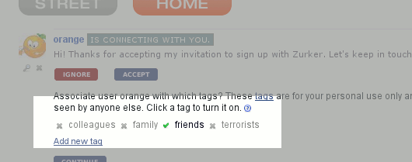
Orange also happens to be a first cousin. So we also click on 'family' and add that tag.
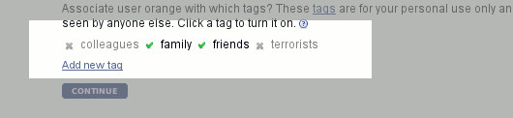
But Orange is also a resident of our local neighborhood. While your account does come with some default tags (which you can, incidentally, erase), it doesn't have a tag for 'neighborhood'. So we add a new tag for the neighborhood, by clicking on Add new tag and entering the name of our 'hood, then click CONTINUE.
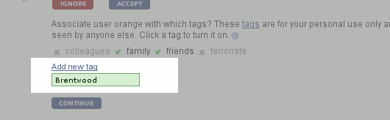
Checking under Contacts shows that Orange is, indeed, associated with the correct tags. The member's tags can be edited under Contacts, or on his/her profile page.
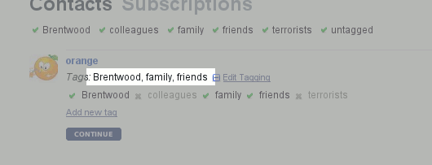
What happens on Zurker is fed to you via the Street. On the Street you can turn tags on or off, to determine what information you see. With the following setting, all tags are on and you get everything - updates, photos, finds, comments and zurks from every single person in your network.
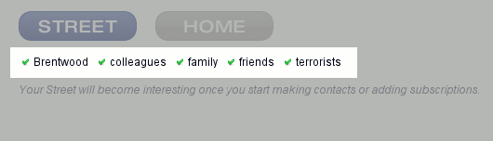
Sometimes news from everyone is too much to process, or not what you're specifically interested in. Filter members using the tags - simply uncheck the tags. If you uncheck 'Brentwood', 'family', and 'terrorists', you only see updates from members associated with the 'colleagues' or 'friends' tags.
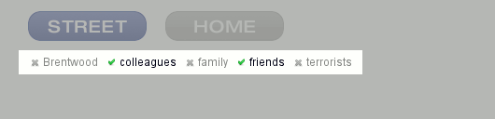
It gets better. When you post an update, you can determine who gets alerted about it. We call this your Broadcast Audience, and it is controlled by tags. Again, uncheck or check tags to turn them on or off. In the following example, only those people you've associated with the tags 'Brentwood', 'friends' and 'terrorists' will receive news about your update.
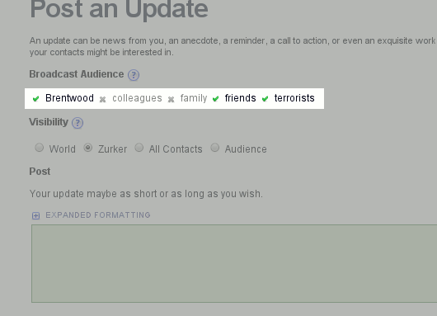
In conclusion, tagging is an easy, quick, and precise way of controlling what you see and what you let others see. Once you get used to tags, you'll wonder how you ever managed without them.

- Updates, Finds and Photos

If you write something, whether its just three words or a 5,000 words long essay , its called an “Update”.

Finds are links from the web, such as websites, pictures, videos, news stories, blog entries, and so on. If your post is specifically to share a link, then use Find instead of Update.

Photos are... photos. You can keep them in albums. You can specify the audience and the visibility (who gets notified about it and who sees it) for each individual photo, or you can let the default album settings take effect. Other members can zurk or comment on your posts, photos, and finds.

It's not a bad thing for a social network to make money, but if squeezing every last penny from the user base is the abiding concern, the users aren't going to get the best possible product.

- Profile Notes
Members may leave each other notes on their profiles. While the note is directed specifically at that member, others can see it and join in the conversation (unless restricted by the profile owner). Leaving a note is the perfect way to congratulate a colleague who just got a promotion, to wish a member luck for a trip, or even to welcome a new member to Zurker. Profile notes are more open than Convos (private messages), and more specific than Updates.

- Comments
Comments are super important, and a critical mode of communication on Zurker. If your contacts leave a note, post an update, share a find, or upload a photo, you can zurk and/or you can add a comment.
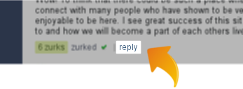

- Convos
Convos (i.e. conversations) are Zurker's equivalent of private messaging or email. You can start a convo with just one other member or several. Only those involved in the convo will know about it. You can attach files to your convo, and more features are coming.
- Entities
Entities are what our friends at Palo Alto call "pages". These are profiles for companies, organizations, bands, movements, and so on. Entities can post items such as photos just like regular members, and members can subscribe to entities just as they do to other members.
- vShares
vShares make the world go round. vShares are stakes of ownership in Zurker. You can actually own a slice of the company that runs Zurker.
- Open Books
Zurker is unique in that we practice open-book accounting, called Open Books. Every cent we receive and spend is recorded in full public view. It may seem inconceivable to some to run a business without any secrets. Zurker believes that in the near future, it will be inconceivable to run a business with anything less than full transparency.
So, the bottomline of Zurker is get in the deal by joining Zurker, refer friends, and by making them your referral you get vshares which will get more valuable as time passes and the site gets more priceworthy. Zurker is in the early stages. So, it needs our cooperation.
Siddhi and Sanika

